**John Deere Quiz 2018:**

The John Deere quiz was organized on 31st October 2018. The motto behind organizing this quiz was to make students aware about the companies profile and their products. **John Deere** is the brand name of Deere & Company, an American corporation that manufactures agricultural, construction, and forestry machinery, diesel engines, drivetrains (axles, transmissions, gearboxes) used in heavy equipment, and lawn care equipment. Total 115 students took part in this quiz which was held in CCF phase 1. Dr. V. B. Dharmadhikari sir has prepared the test along with the coordinator from John Deere Company.

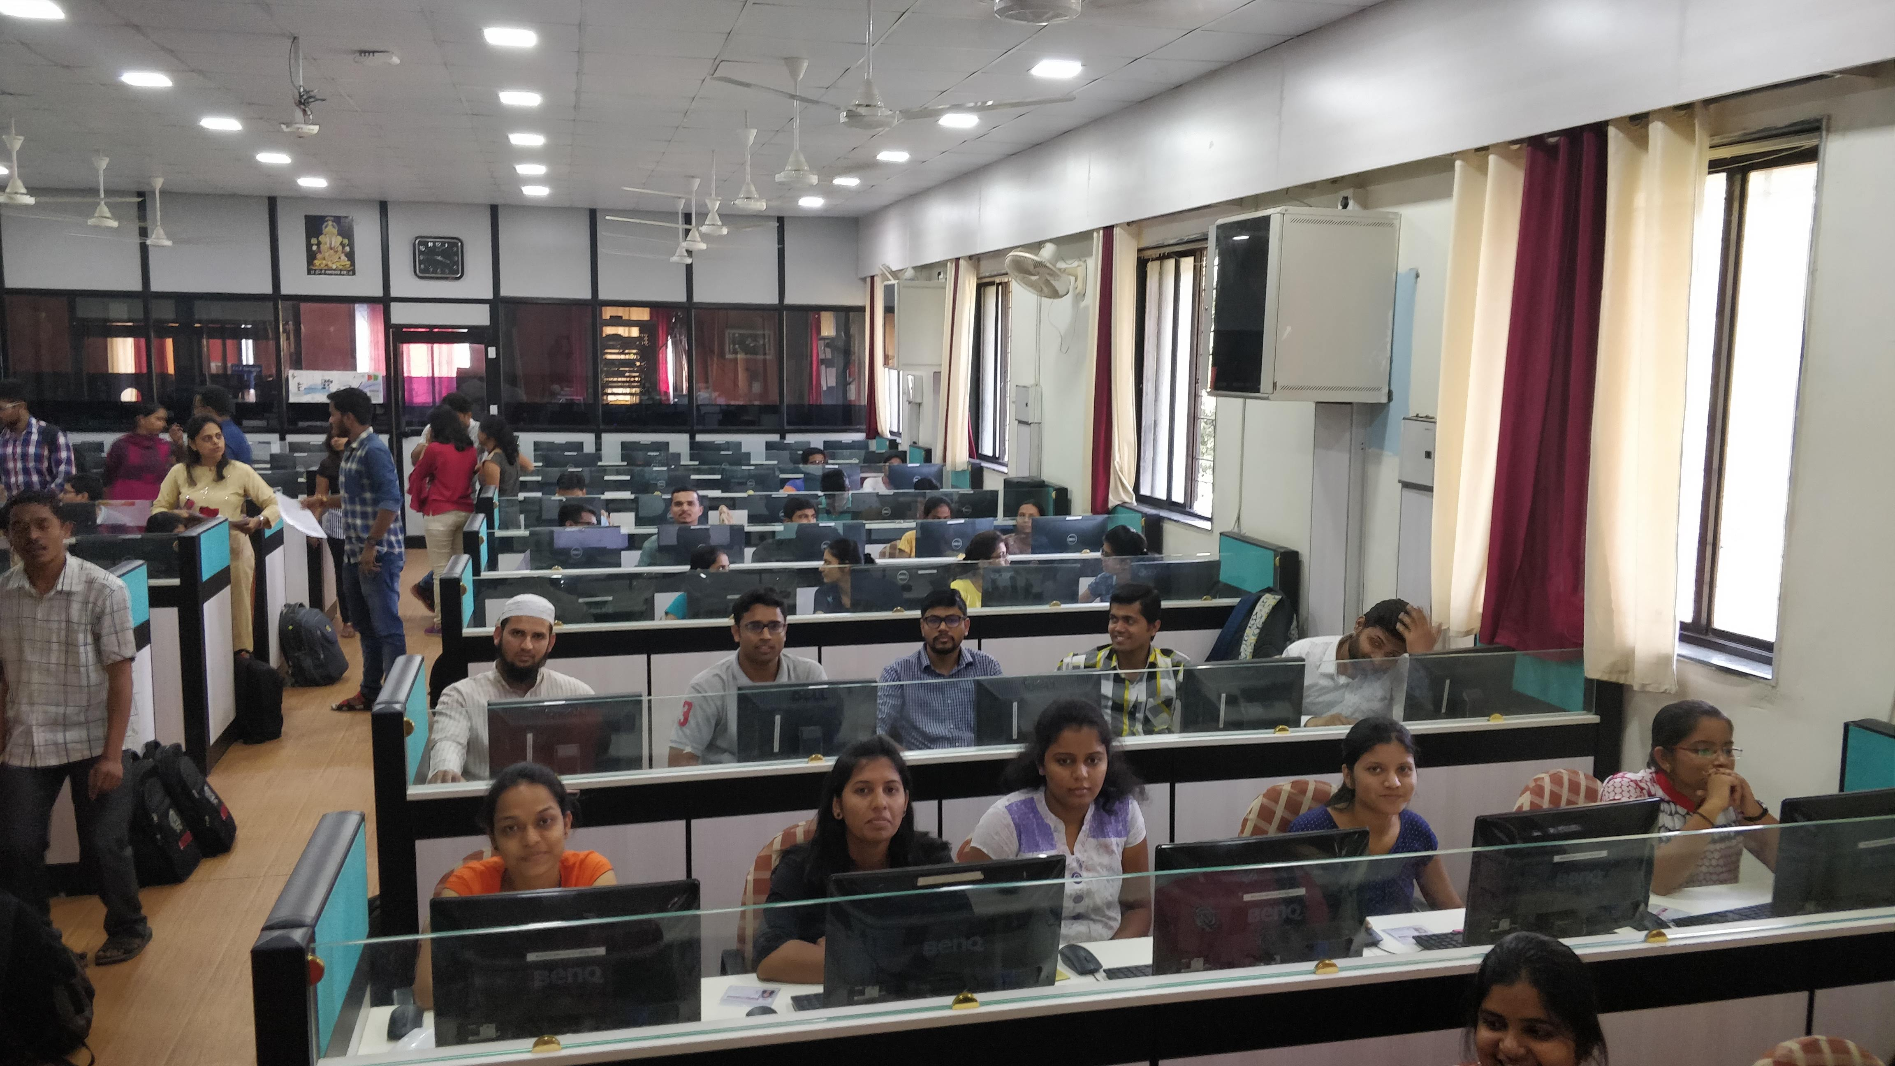

It was an online test with each students having unique login ID and password. The test was divided into two parts. The first part consisting of 80 questions which tests the student’s knowledge regarding the companies profile and its products. The second part consist of questions regarding personal information of students and their background related to agriculture.

The prize distribution ceremony was held on 1st November 2018. The prizes to the winners was given by the Sandeep Joshi, who is the Director of Asia Technology Innovation Center at John Deere

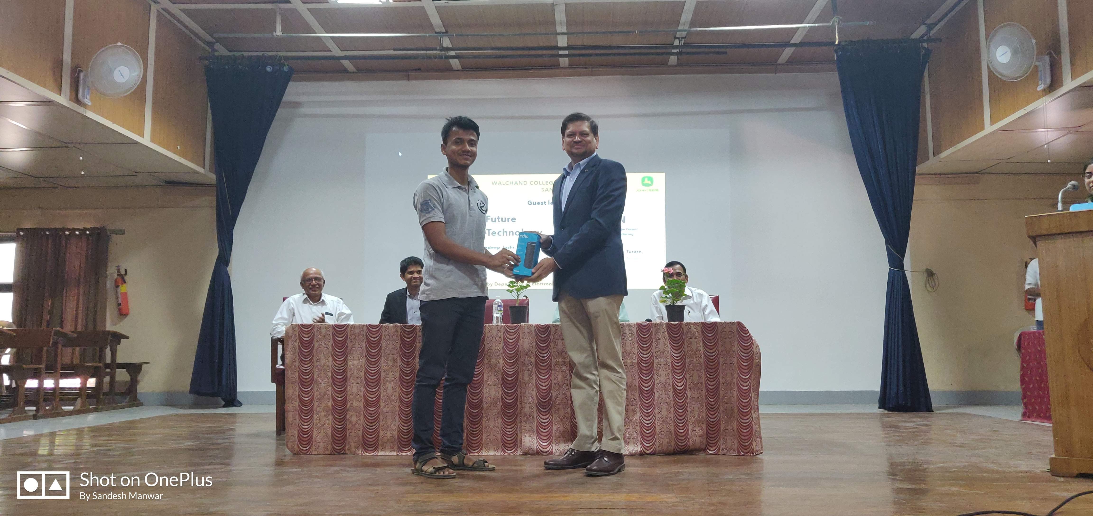

**Guest lectures on Future Agro-Technology**

The lecture was organized on 1st November 2018 in Tilak Hall at WCE Sangli. The lecturers were Mr. Sandeep Joshi who is Director at Asia Technology Innovation Centre, Mr. Dinesh Phatak, who is Senior Technical Specialist in Advanced Embedded Systems at John Deere Pune. The Director of WCE Sangli Dr. G. V. Parishwad sir initiated the program by giving brief information about the speakers and the various activities that college is doing.

Mr. Sandeep Joshi sir spoke about the history of John Deere company and its current state in market. He also shared the ideas about how the company is doing innovation in the field of agriculture. He later also talked about the personality development.

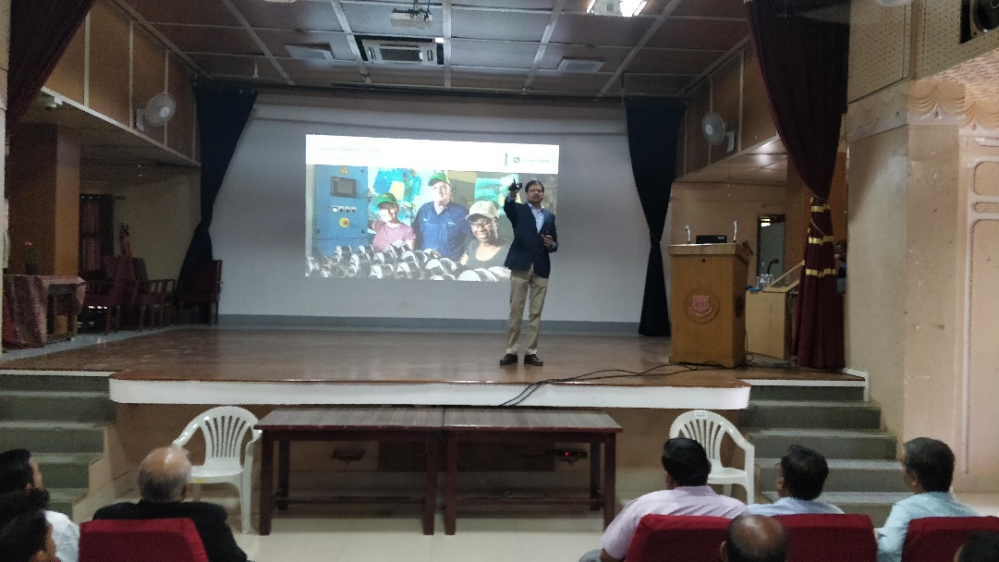

Mr. Dinesh Phatak talked about the projects which are currently going on in John Deere. He is being technical person mainly focused on the technical part and about the technology. He also clarified the various doubts raised by students about technology. 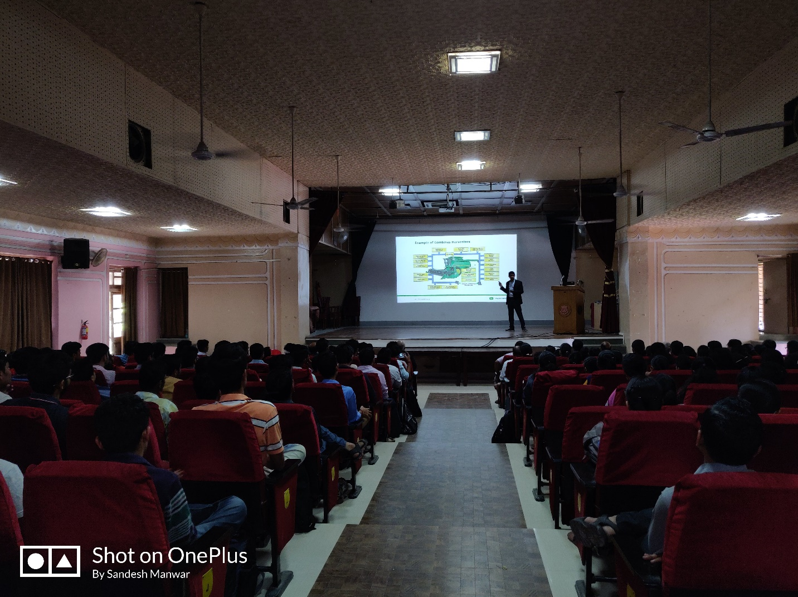

Mr. Chandakant Turare talked about TIFAN i.e. Technology Innovation Forum for Agricultural Nurturing which is the India level students competition. He talked about the benefits of this competition and also showed the videos of previously held competition.

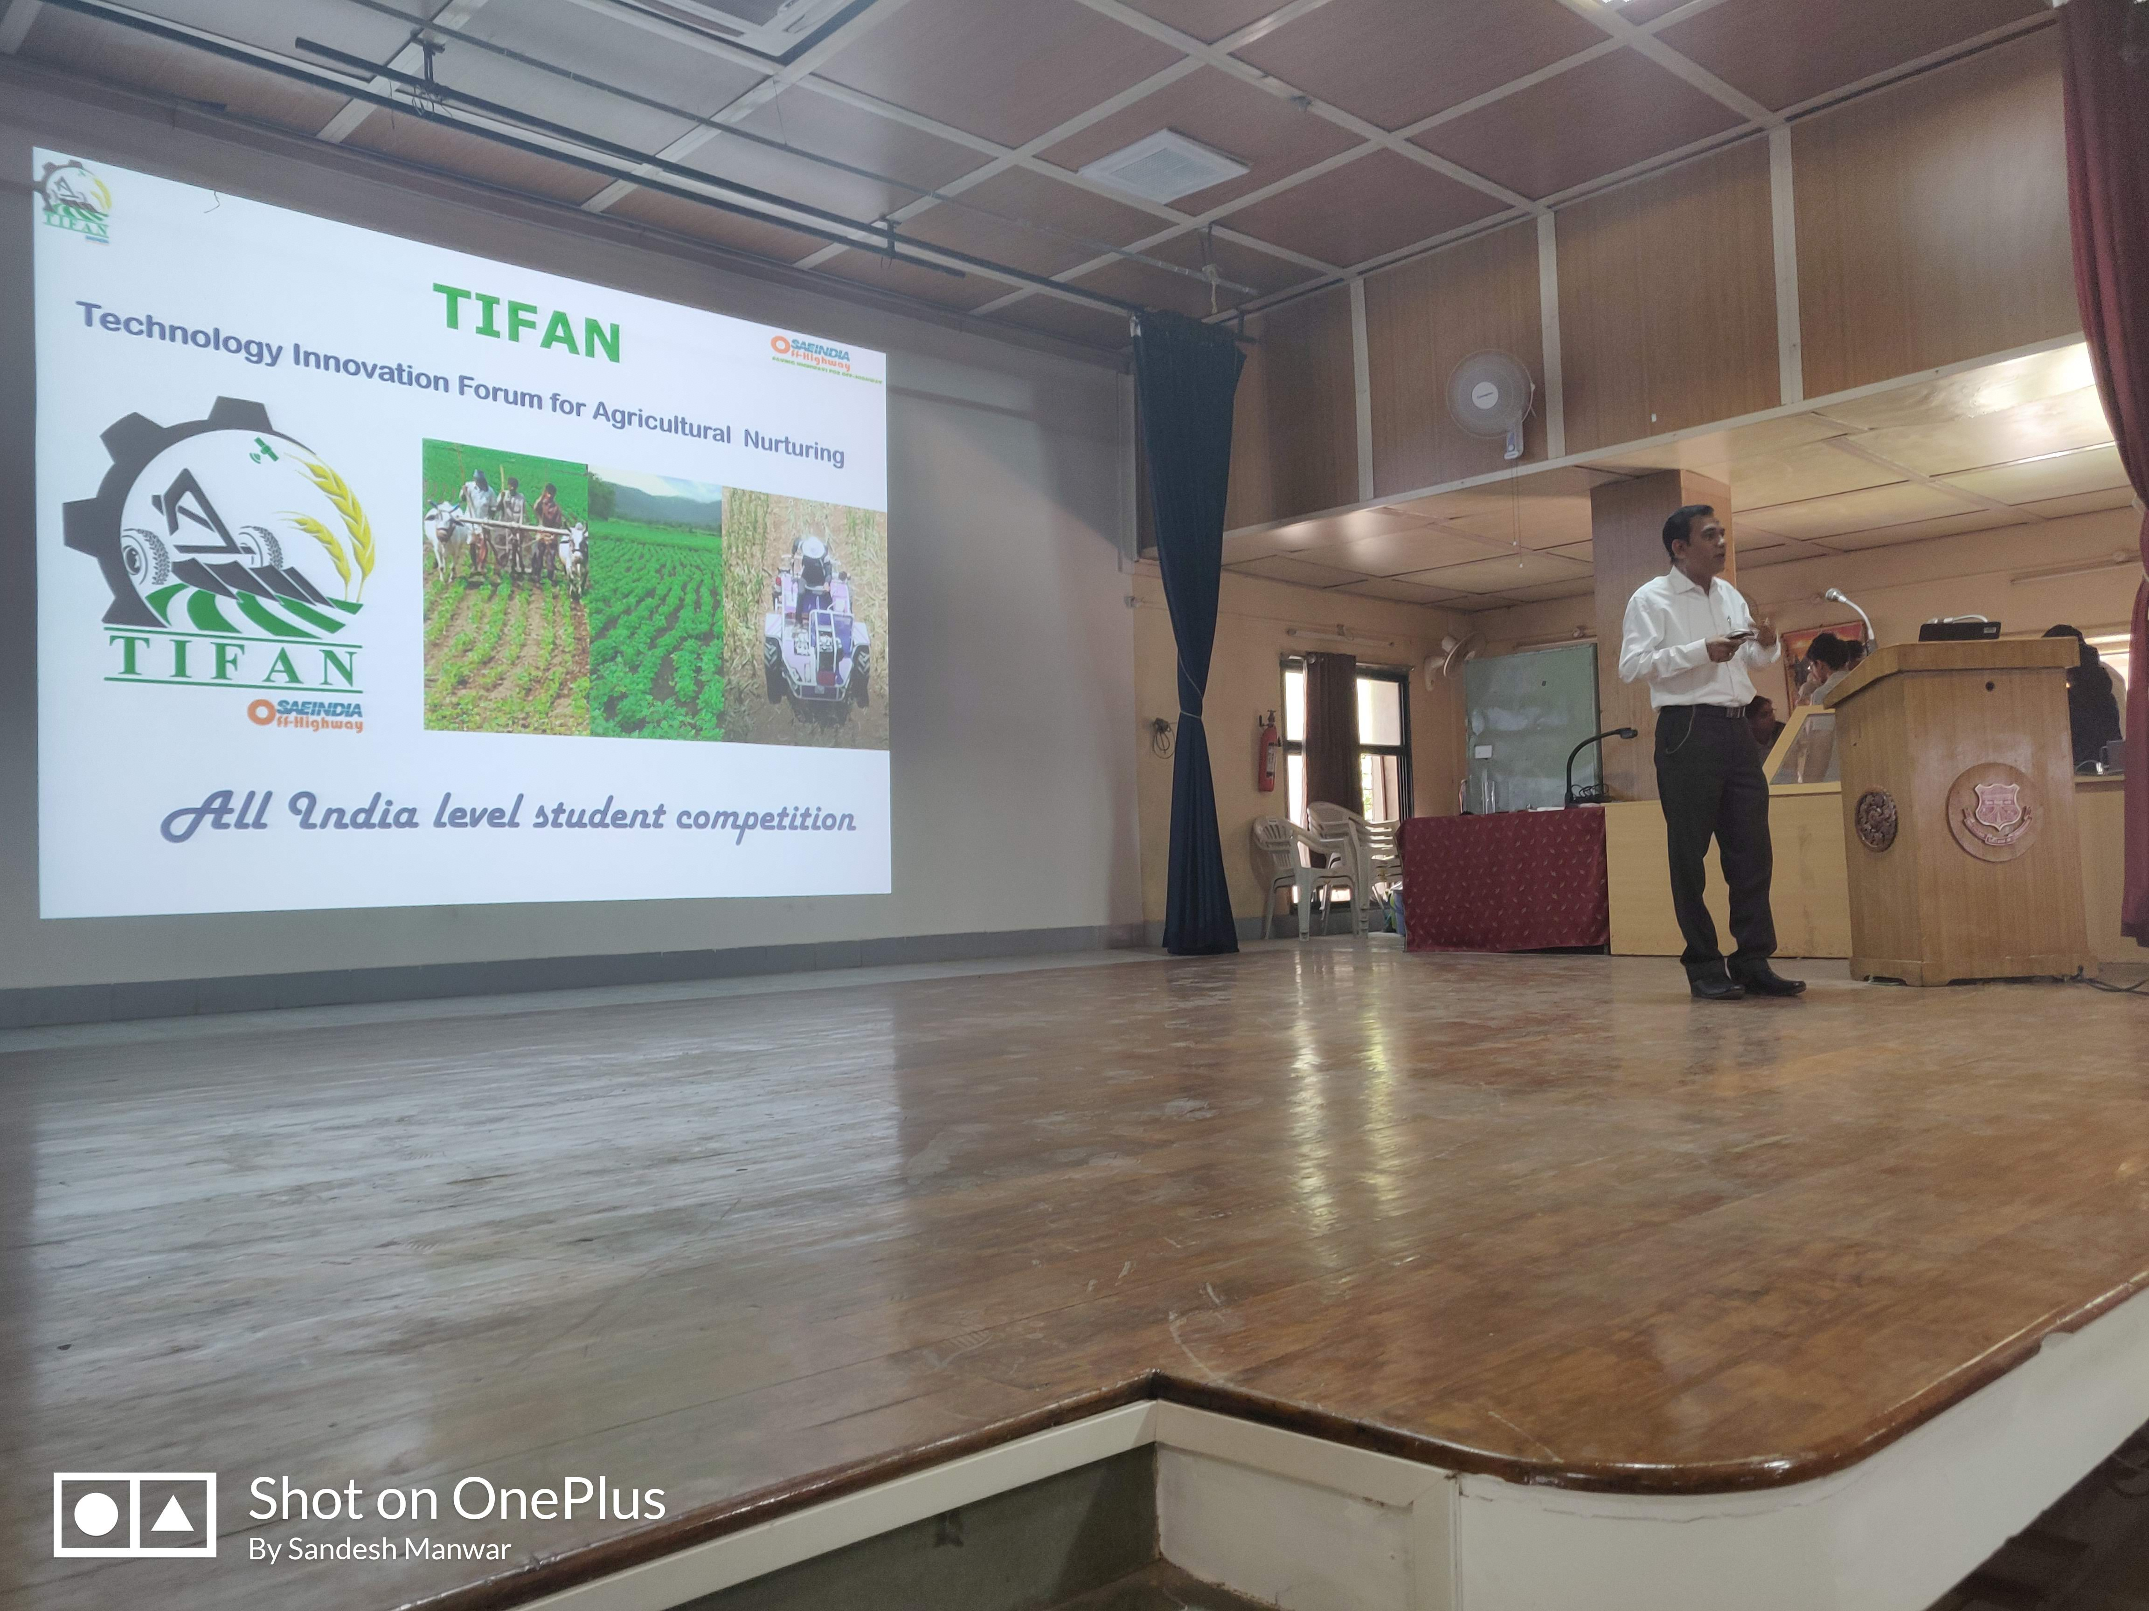

**Project Presentation:**

The project presentation was held in John Deere lab where 16 different projects were kept for an exhibition. The exhibition was arranged just after the prize distribution ceremony. The idea behind this exhibition was to take guidance from industry level experts on various project that are undergoing in WCE. Guest really liked the projects and they also gave a valuable feedback to students.

